**General Block Diagram**

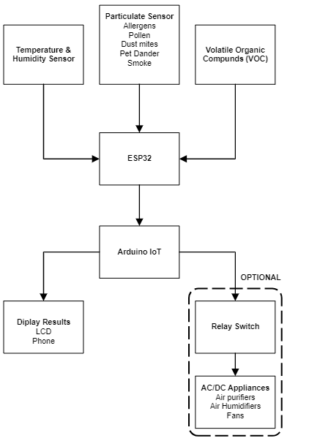

**Hardware Functional Block Diagram**

**Software Functional Block Diagram**

